Manual Password Reset on Mac (Including Admin Accounts)
Official URL: https://services.smsu.edu/TDClient/180/Portal/KB/Article/5315/Manual-Password-Reset-on-Mac-Including-Admin-Accounts
Category: Knowledge Base > Information Technology Services > Internal > Manual Password Reset on Mac (Including Admin Accounts)
Tags: None
_____________________________________________________

Overview
Step 1: Log in via FileVault
- At the FileVault login screen, use an account that has previously logged into the computer.
Typically, smsuadmin with the default password works.
If the device has been offline for a while, the password in Jamf may differ, so smsuadmin might not work.
- Typically, smsuadmin with the default password works.
- If the device has been offline for a while, the password in Jamf may differ, so smsuadmin might not work.
Step 2: Check Internet Connection
- Confirm the Mac is connected to the internet (bottom-left corner of the screen).
- If connected:
You can log in with a new StarID account or
Use an account that has been on the device before.
- You can log in with a new StarID account or
- Use an account that has been on the device before.

Step 3: Gain Admin Access
- Once logged in, open Self Service.
- Run Make Me Admin and confirm the change.

Figure 1: Uploaded Image (Thumbnail)

Step 4: Reset the User’s Password
- Go to System Settings → Users & Groups.
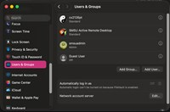
Figure 2: Uploaded Image (Thumbnail)
- Click the info (i) icon next to the user you want to reset.
If the user is a Standard User:
Click change and reset their password to a temporary one.
If the user is an Admin:
Resetting the password alone will not work. You must also reset their keychain.
- If the user is a Standard User:
Click change and reset their password to a temporary one.
- Click change and reset their password to a temporary one.
- If the user is an Admin:
Resetting the password alone will not work. You must also reset their keychain.
- Resetting the password alone will not work. You must also reset their keychain.
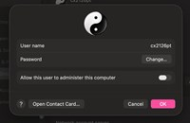
Figure 3: Uploaded Image (Thumbnail)

Step 5: Reset Keychain (Admin Accounts Only)
- Open Keychain Access while you are still an admin.
- In the top menu bar, click Keychain Access → Settings.
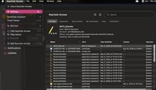
Figure 4: Uploaded Image (Thumbnail)
- Select Reset Keychains to Default.

Figure 5: Uploaded Image (Thumbnail)
- Follow the prompts carefully:
This will reset ALL saved logins.
Warn the user: they will need to log back into everything later.
- This will reset ALL saved logins.
- Warn the user: they will need to log back into everything later.

Step 6: Finalize Password Reset
- Return to Users & Groups and set a temporary password for the account.
- Ensure the Mac is still connected to the internet.
- Log out from the admin account.
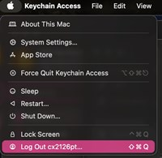
Figure 6: Uploaded Image (Thumbnail)

Step 7: Sync the Password
- Log in with the user’s StarID and current password.
- A popup will appear asking to sync with the old password:
Enter the temporary password you set.
- Enter the temporary password you set.
- This will sync the account with the updated StarID password.

Step 8: Verify Network & Cisco
- Follow the Fixing Network Connection on Mac instructions.
- Confirm Cisco can connect successfully.

Step 9: Wrap-Up
- Inform the user they will need to log back into all apps and services.
- If time allows, assist them with re-login steps.
- Once verified, the project is complete.

Accessibility Review & Update Log:
- [x] Content accuracy and link integrity verified
- [x] High-contrast visual hierarchy implemented (Inter and Calibri)
- [x] Image alt-text captions verified (all screenshots captioned)
- [x] Outline headers and standard list sequences optimized for screen readers

